EASTERN GOLDFIELDS COLLEGE
Maths Methods year 12
EXTENDED PIECE OF WORK
LOGARITHMIC FUNCTIONS

NAME:_________________________ 60 minutes 36 marks
Complete the following investigation to find the effect of transformations on logarithmic functions.

1. (2, 6, 3 marks)
(a) On the axes below, sketch the graph of the function 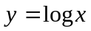 for 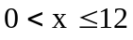.

(b) On the same set of axes, investigate the graphs of 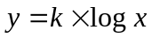 for the following integer values of k = -2, -1, 2. Clearly label each graph.
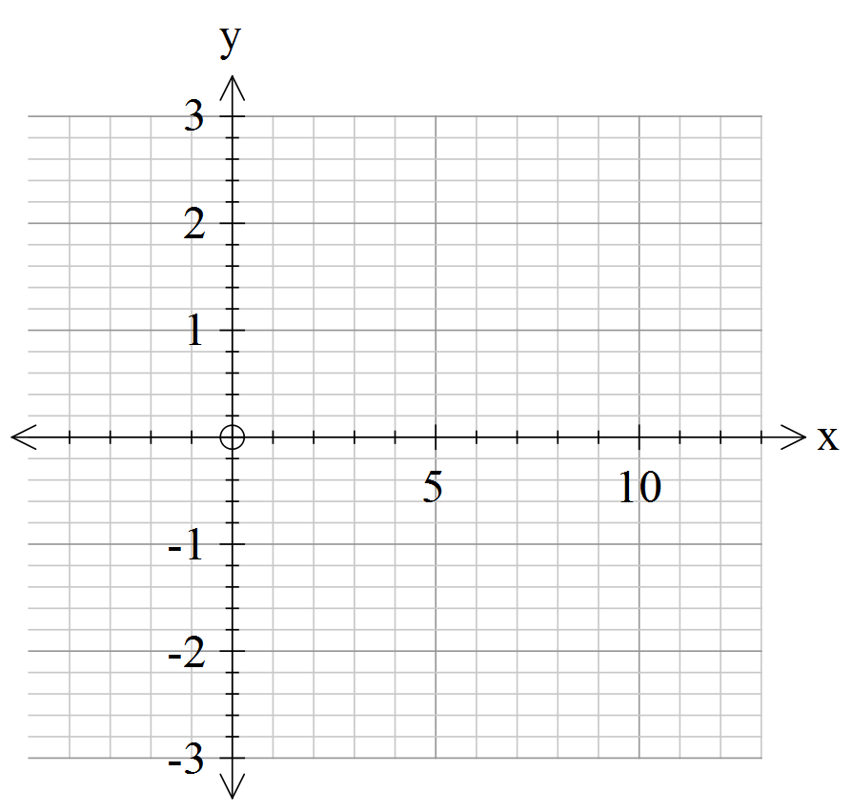

(c) Write a short summary showing any information you have found that would help you identify graphs of the form

2. (3, 3, 3 marks)
In a similar manner, investigate the following functions for various integer values of k.
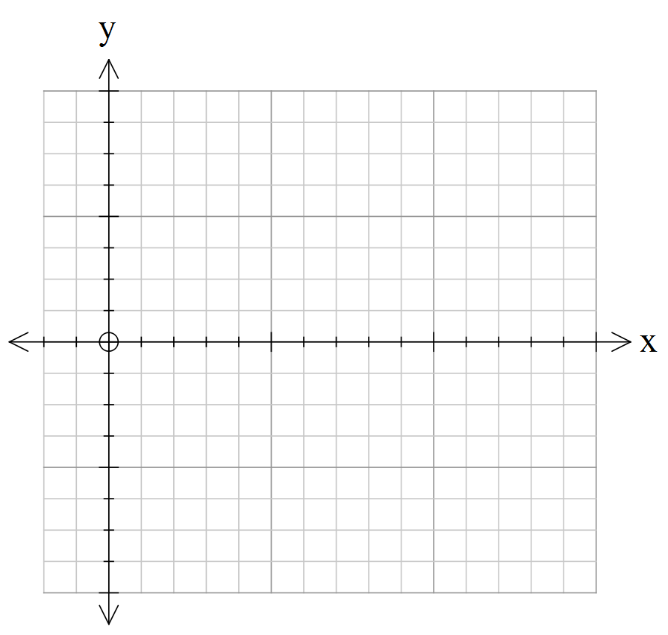

(a) 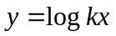

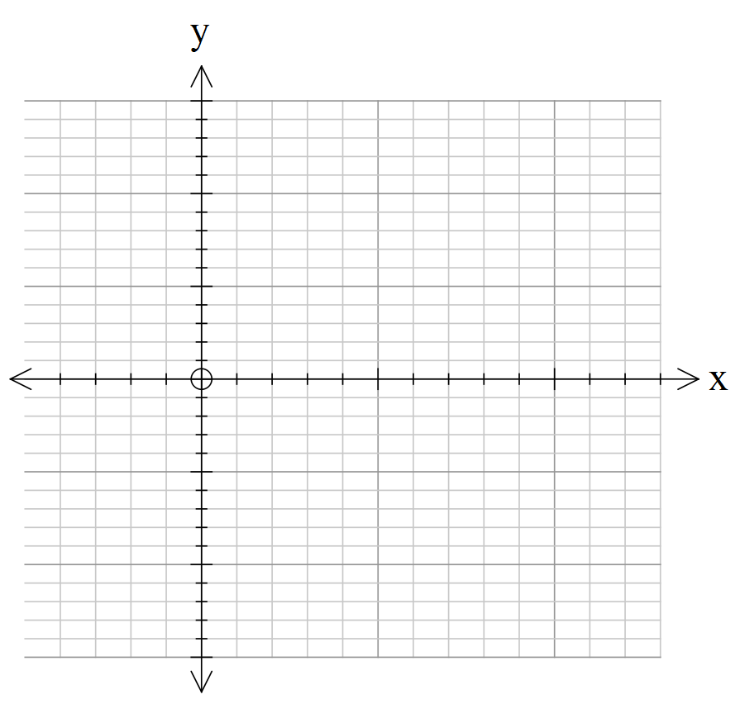

(b) 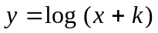

(c) 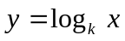

Use your investigations of the above functions to answer the following questions.
3. (6 marks)
The following graphs are transformations of the graph 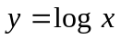.
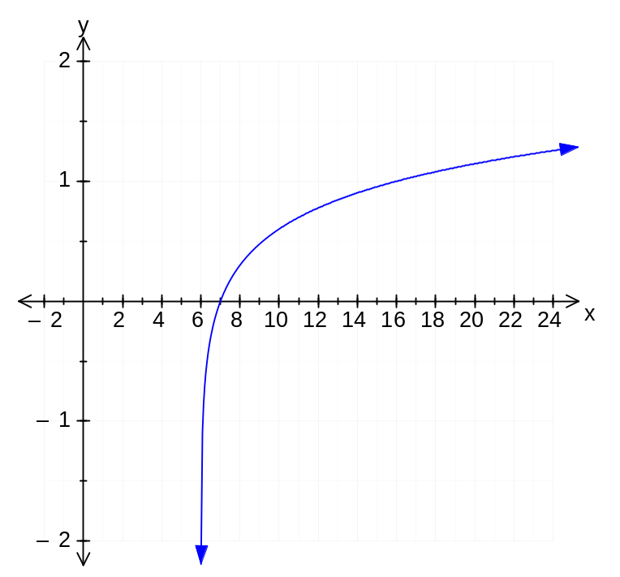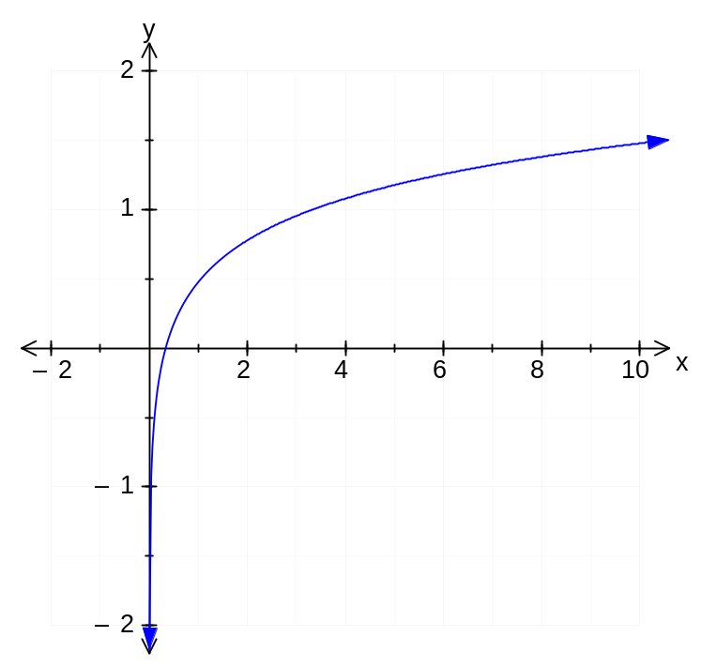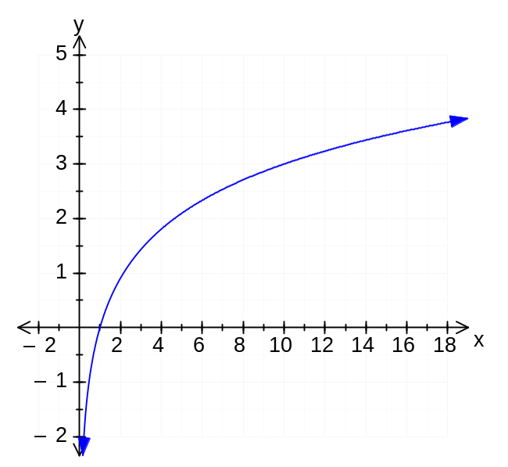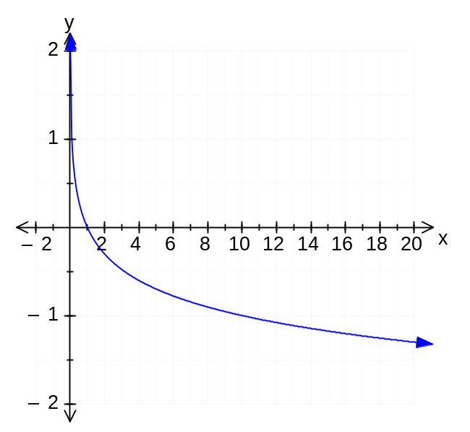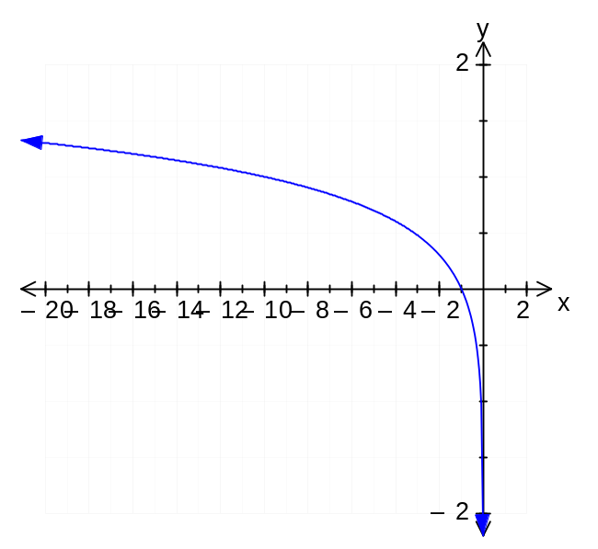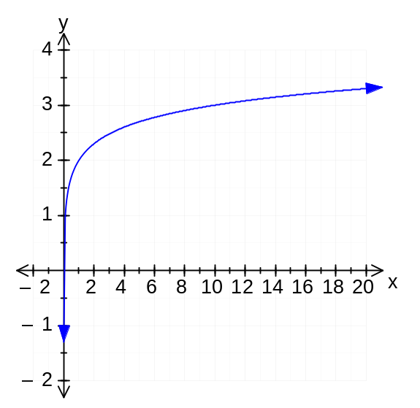State the equation of each function.
4. (2, 2 marks)
The function graphed in each of the following graphs is of the form 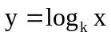.
Examine the graph and then determine the equation.
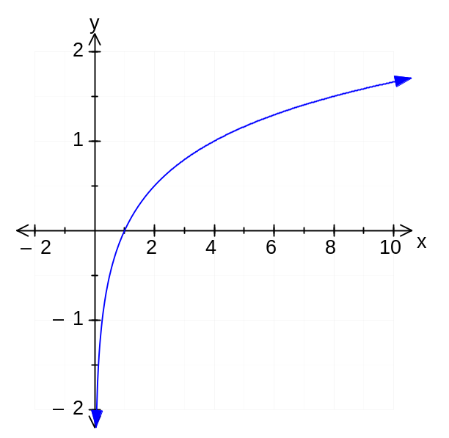

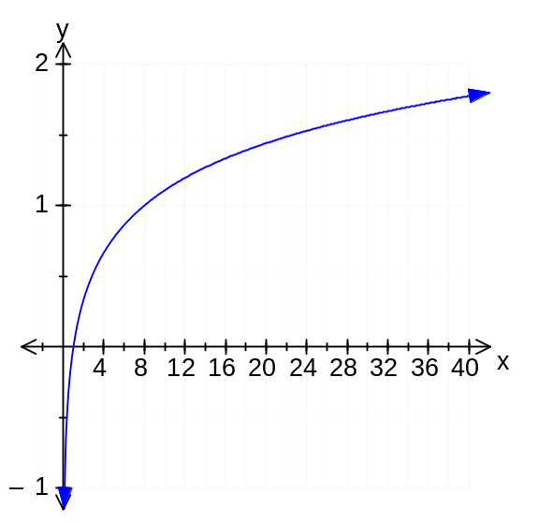y =______________ y=_____________

5. (2, 2 marks)
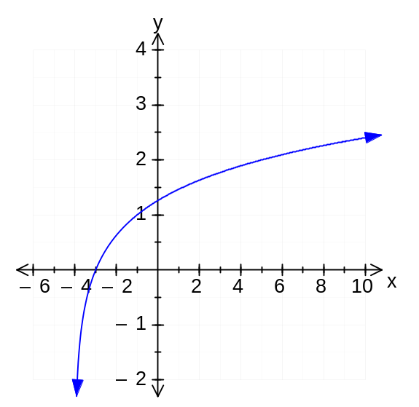Determine the equation of the function graphed in each of the following, given that the graph is a transformation of the graph of 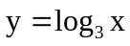.

y =______________________ y =__________________
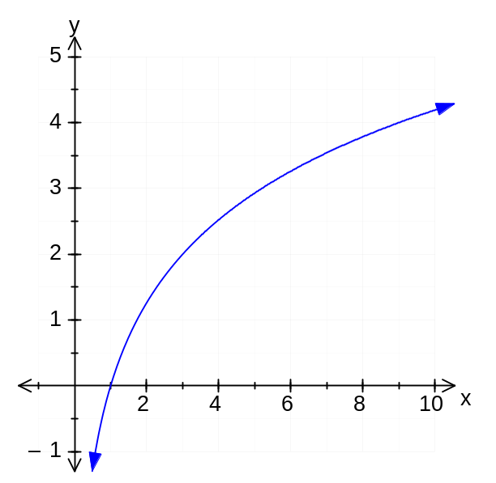

6.(2 marks)
The following graph is a function of the form 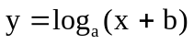. Determine the values of a and b.

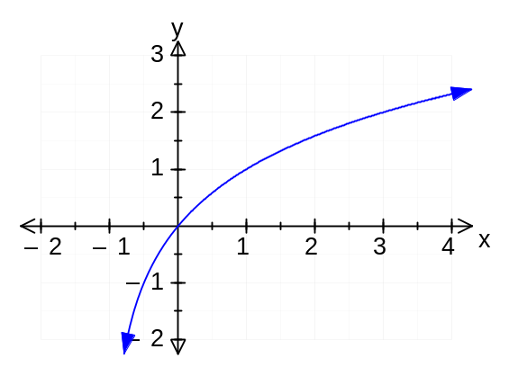y =_______________________

